Internship

**TestReport**

**Voicecoil driver**

**Student:** Casper R. Tak

**Studentnumber:** 657313

**Client**: Rudie van den Heuvel

**Coach:** Jeroen Veen

**High School:** HAN Arnhem

**Education:** Embedded Systems Engineering

**Date:** 09-11-2022

Inhoud

Objective 3

Test Setup 3

Test Results 4

Conclusions 5

Further actions 5

# Objective

The component that will be tested in this test report will be the voice coil driver (DRV8838). This component is responsible for driving the voice coil up and down to focus the lens of the camera.

# Test Setup

* Testing equipment:
  + Hardware:
    - Zaleae Logic 16
  + Software:
    - VSC
    - SSH connection to RPI
    - Logic 2.3.45
* Setup hardware/software

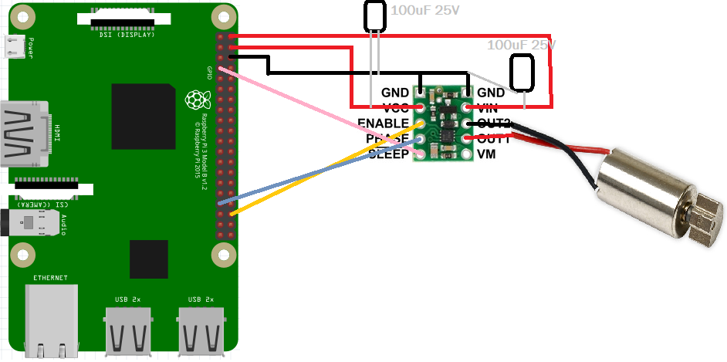

# Test Results

|  |  |  |  |  |  |  |
| --- | --- | --- | --- | --- | --- | --- |
| Test | Test passed if: | Observations | Test passed | Test Failed | Pictures | Notes |
| T1.0 | Driver gets disabled | Logic analyzer shows LOW on sleep pin | X |  |  | Phase pin was undefined, can be ignored |
| T1.1 | Driver gets enabled | Logic analyzer shows HIGH on sleep pin | X |  |  |  |
| T2.0 | Motor shaft turns clockwise | Motor turns clockwise | X |  |  |  |
| T2.1 | Motor shaft turns counterclockwise | Motor turns counter clockwise, phase changes | X |  |  |  |
| T2.2 | Variable speed control | Motor turns at a different speed (increasing) | X |  |  |  |

# Conclusions

* The driver seems to be functioning correctly. The motor is driving the way it is intended to with variable speed an direction options.

# Further actions

* There is an error on the schematic for the PCB design -> VCC is not connected, however it should be connected to 3.3V or 5V for the driver to function.